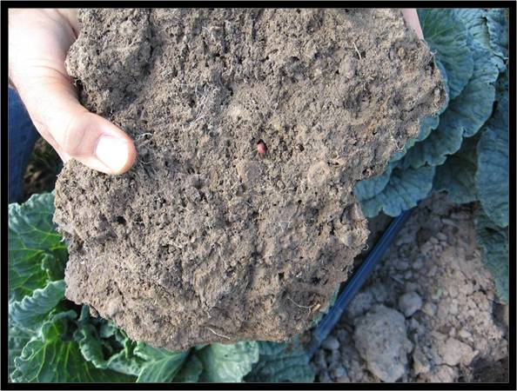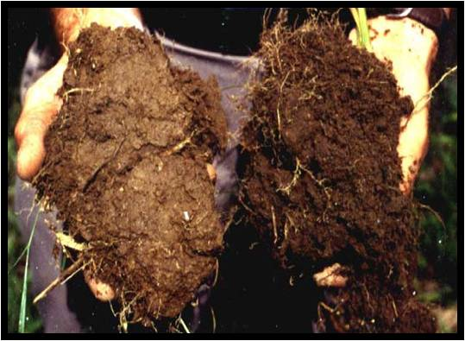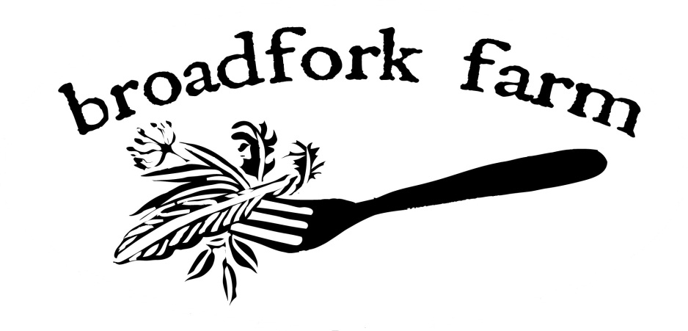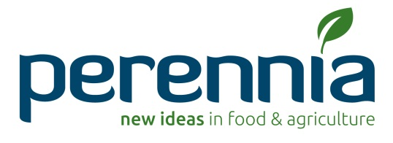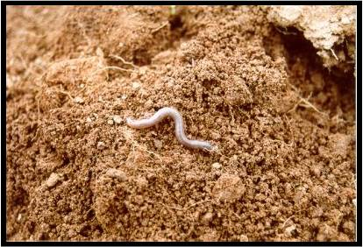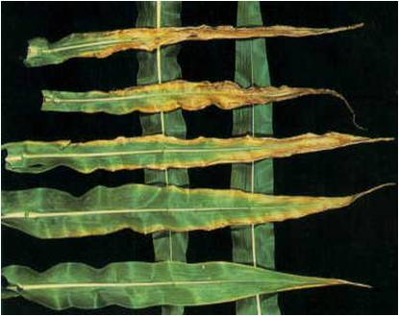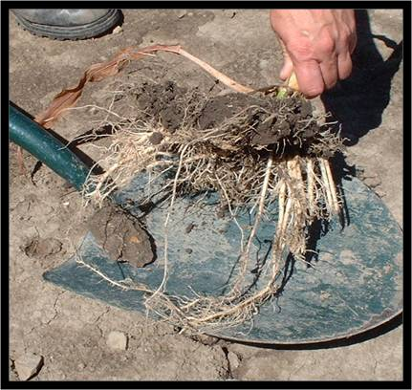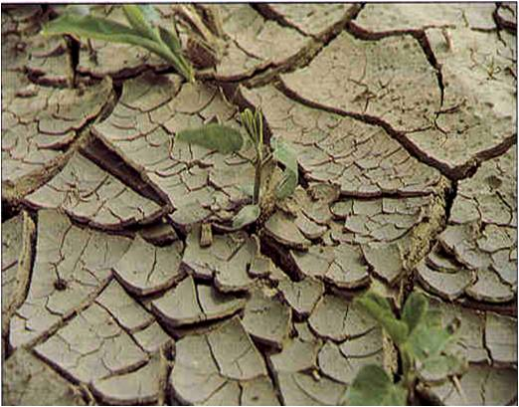

**Hosts Shannon Jones and Bryan Dyck will welcome you on**

**Monday September 10th at 1:00 PM at Broadfork Farm (River Hebert, NS)**

Perennia Soil Specialist, ***Amy Sangster*** and Organic Specialist, ***Av Singh*** will facilitate a discussion on interpreting soil tests and assessing soil health using sensory tools

For more information please call (902) 890-5899

**Signals from the Soil:**

Using common and other senses to determine soil health