Are You Interested in Local Healthy Food and Your Community?

Join us on October 15th, for the Cumberland Food Action Network (CFAN) “Leaders Among Us” sharing day. We are a group of people who are interested in seeing change in our communities toward a more accessible, sustainable healthy local food system. The day will provide an opportunity to plant some seeds with like minded people in our county about things like: how to start a community garden, connecting and supporting local producers, how to host a canning or cooking workshop, access to healthy food and what that means, and other opportunities for food action in your community.

Date: Monday, October 15
Time: 8:30AM – 4:00PM
Where: Nappan Experimental Farm Pavillion

“Local” Lunch and Nutrition Breaks Provided. Workshop is free.

Space is limited and you must register: Call 902-667-7250
Or
Email: Cumberland Food Action Network at cumberlandfoodactionnetwork@gmail.com

Directions: Route 2 away from Amherst towards Springhill until you reach the Pied Piper Motel; turn right on Route 302 and proceed 5 kms to the Nappan Experimental Farm. The Pavilion is to the right of the main office building. (Look for our signs)

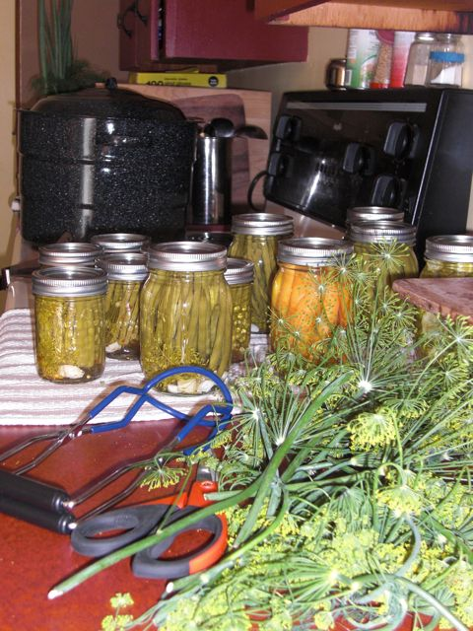Funding Support for this project provided by the
Rural Communities Foundation of Nova Scotia-
Under the Rural Leadership Initiative.

